WAA Parent Meeting
4/23/18
- Hotels/rooming situations
  - This is on the website
  - Http://washoeacademyabroad.weebly.com/

Hotels 2018 tour

Prague July 9-10: http://internationalprague.cz/en/

Impressive old communist structure built as an academy for the officers of the Czech army with a lot of history and stories to be told. Very typical and very safe residential area around the hotel.

Füssen July 11-13: http://www.hotel-ruchti.de/hotel-fuessen-germany.html

110+ Within easy walking distance to the old town center, nice scenery with a park in front of the hotel.

Salzburg July 14-15: https://www.jufa.eu/hotel/salzburg/

BEAUTIFUL location below the castle. It’s a little bit of a walk through the old town and across the river to the concert hall, but the free time in Salzburg will be awesome with our access to so many sights.

Lake Garda/Busselengo July 16-17: http://www.montresorhotels.com/hotel-tower/en/home

I admit that the location in the town center is not as attractive as on the surrounding hills but the place itself is wonderful, and the food and service last year was excellent!

Wengen July 18-19: http://www.hotel-victoria-lauberhorn.ch/index.php?id=74&L=2

Very happy with this classic old jewel from former times. The access is gorgeous and adventurous, as Wengen is traffic free. We have to park the bus in Lauterbrunnen, then get on a train with our luggage and travel up to Wengen. Same on the way back. Should be fun!

Reims July 20 http://www.hotel-bb.com/en/hotels/reims-centre-gare.htm?utm Close to the historic church and town center. This area is expensive but we found this little gem that fit our budget and will work just great!

Bayeux July 21
https://www.campanile.com/fr/hotels/campanile-bayeux?utm

Cute, kind of old farm-looking buildings with great views of the gothic cathedral in town and close to the tapestry museum.

Compiègne July 22 - 24 http://www.mercure.com/gb/hotel-1623-mercure-compiegne-sud-hotel/index.shtml

This is a very nice place north of Paris. Safe location, easy access to the freeway and to the airport. If you recognize the name it’s because the armistice that ended WWI (On 11/11/18 at 11:00) was signed here! On a dirty trick by Hitler, he made the defeated French sign an armistice in 1940 in the same railroad car, but he switched the seats!!
Most hotels will be double rooms, but could have other combinations in Fussen and Wengen…
- Fussen Pen-pals

- 3 Dinners on their own
  - Salzburg, Verona, Paris
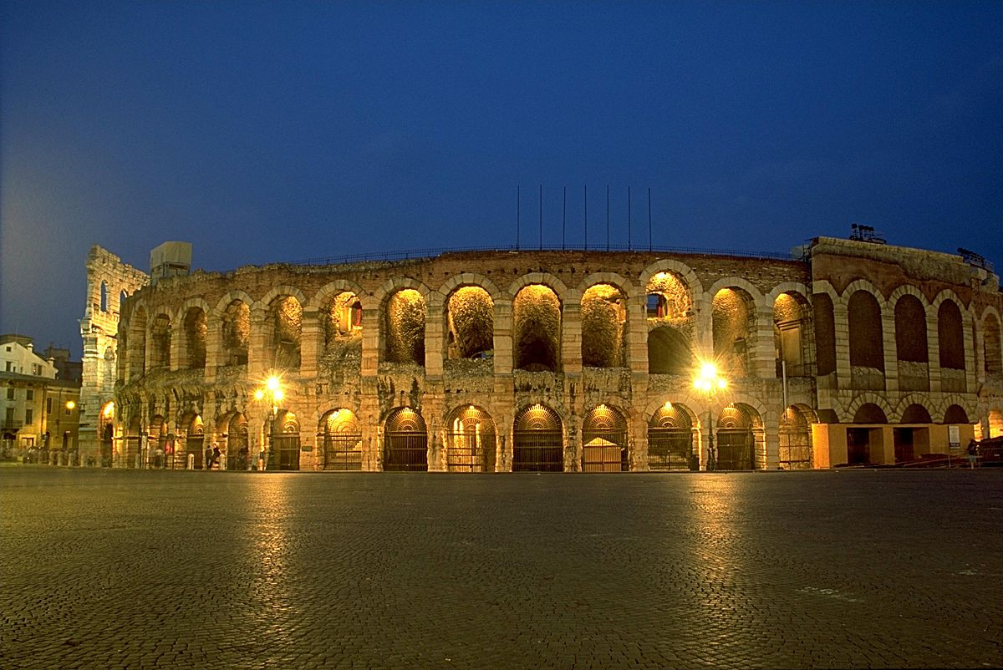

- Concert In Salzburg
  - Beautiful old hall, that Mozart actually performed in!
  - Dress code…

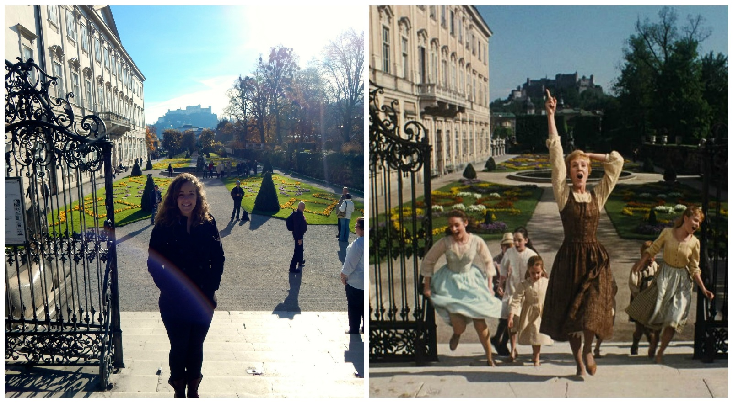

- Bon Voyage party
  - Someone’s house? Park? Pot luck? Pizza place???

- Money in now and final payments
  - You can always email Barry and he’ll give you your total
  - Final payment due 5/15

- Emergency phone contact
  - Call your carrier

- Debit accounts and money over there
  - Handout

- Passport numbers
  - Need them for Hotel check-in
  - Please send them to me if I don’t have them already

- Money belt/passport holder
  - Goofy but necessary

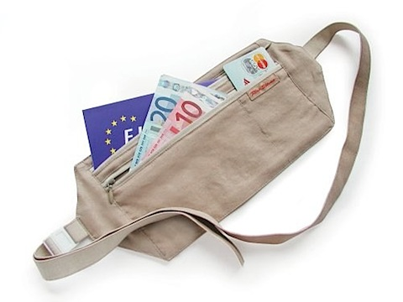

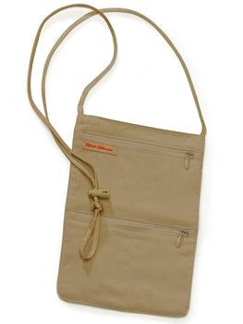

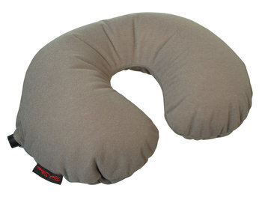

- Plugs and appliances!

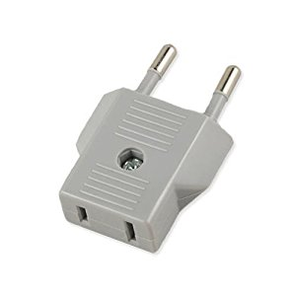

- Eiffel Tower Excursion
  - We are purchasing these tickets tomorrow- anyone afraid of heights or does not want to go?

