Cash and Currency Tips for Europe
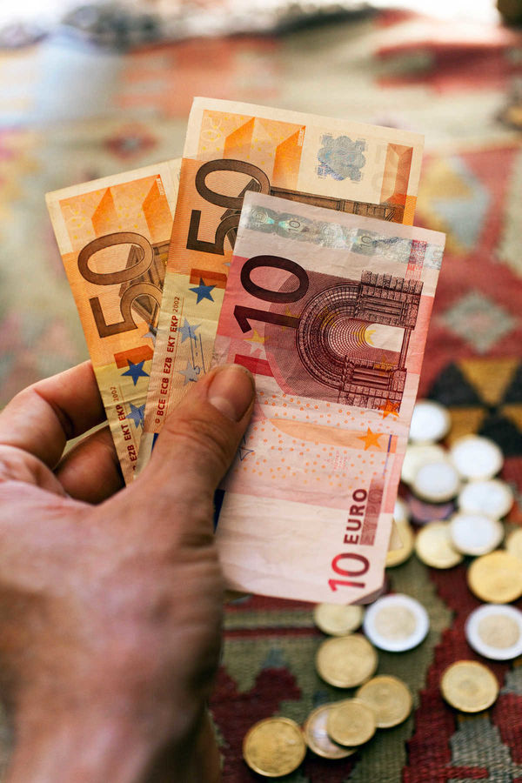

By Rick Steves

Money-wise, Europe's never been easier. Thanks to the ubiquity of cash machines and the widespread use of a single currency, gone are the days of having to go to your hometown bank for travelers' checks or foreign cash, of lining up at AmEx offices overseas, or getting fleeced at exchange bureaus at every border. With the following tips, you'll make the most of every cent you spend.

Resist the urge to buy foreign currency before your trip. Some tourists feel like they just have to have euros or British pounds in their pockets when they step off the airplane, but they pay the price in bad stateside exchange rates. Wait until you arrive to withdraw money. I've yet to see a European airport that didn't have plenty of ATMs.

Don't bother with traveler's checks. They're a waste of time (long lines at slow banks) and money (fees to get them, fees to cash them).

Avoid (or at least minimize) cash exchange. In general, I avoid exchanging money in Europe; it's a big rip-off. On average, at a bank you lose about 8 percent when you change dollars to euros or another foreign currency. When you use an airport currency exchange booth such as Forex or Travelex, the hit can be as much as 15 percent.
But exchanging money can make sense in certain situations, including emergencies (if your card — or the only ATM in town — doesn't work), or when crossing into a country that uses a different currency.
If you do need to exchange money, look for places that don't charge a commission. Note the difference between the rates for buying (the bank buys foreign currency from you to exchange into local cash) and selling (the bank sells foreign currency to you). A good rule of thumb: The difference between the buy and sell rates should be less than 10 percent.

Use local cash. Many Americans are thrilled to find a store advertising "We accept dollars." But the happy sales clerk doesn't tell you that your purchase is costing about 20 percent more because of the store's terrible exchange rate. Without knowing it, you're changing money — at a lousy rate — every time you buy something with dollars.
Likewise, in some non-eurozone countries, the euro is commonly accepted, but usually a bad deal. For example, in Switzerland, which officially uses Swiss francs, some ATMs give euros, prices in touristy areas are listed in both currencies, and travelers can get by with euro cash. But if you pay in euros, you'll get a rotten exchange rate. Ideally, if you're in a non-euro country for more than a few hours, head to the ATM and use local currency instead.

Use your credit card to get cash only in emergencies. If you lose your debit card, you can use your credit card at an ATM to get a cash advance — but you need to know your PIN, and you'll pay a sizeable cash-advance fee.

Don't stress over currency conversions. Local currencies are all logical. Each system is decimalized just like ours. There are a hundred "little ones" (cents, pence, groszy, stotinki) in every "big one" (euro, pound, złoty, lev). Only the names have been changed — to confuse the tourist. Examine the coins in your pocket soon after you arrive, and in two minutes you'll be comfortable with the nickels, dimes, and quarters of each new currency.
You don't need to constantly consult a currency converter. While you can do real-time conversion with an app, I've never bothered. You just need to know the rough exchange rates. I see no need to have it figured to the third decimal.
Very roughly determine what the unit of currency (euros, kroner, Swiss francs, or whatever) is worth in American dollars. For example, let's say the exchange rate is €1 = $1.10. If a strudel costs €5, then it costs five times $1.10, or $5.50. Ten euros, at this rate, would be about $11, and €250 = $275 (figure 250 plus about one-tenth more). When the euro is that close to the dollar, that difference might not be worth computing — but for, say, the British pound (worth roughly $1.30 lately), or for the euro when the rates aren't as favorable for us, it's more important to mentally adjust the numbers. Make a game out of quizzing yourself or your travel partner, and soon it'll be second nature. Survival on a budget is easier when you're comfortable with the local currency.

Assume you'll be shortchanged. In banks, restaurants, at ticket booths, everywhere — expect to be shortchanged if you don't do your own figuring. Some people who spend their lives sitting in booths for eight hours a day taking money from strangers have no problem stealing from clueless tourists who don't know the local currency. For 10 minutes I observed a man in the Rome subway shortchanging half of the tourists who went through his turnstile. Half of his victims caught him and got their correct change with apologies. Overall, about 25 percent didn't notice and probably went home saying, "Mamma mia, Italy is really expensive."

Plan your cash withdrawals wisely. Avoid having a lot of unused currency left over when you cross borders between countries that use different currencies. (This should also help you minimize withdrawal fees.)

Spend your coins before leaving a currency zone. Since big-value coins are common in Europe, exporting a pocketful of change can be an expensive mistake. Spend them (on knickknacks or snacks), change them into bills, or give them away before you head into a country where they're worthless. Otherwise, you've just bought a bunch of round, flat souvenirs. Note, however, that while euro coins each have a national side (indicating where they were minted), they are perfectly good in any country that uses the euro currency.

What to Bring
I pack the following and keep it all safe in my moneybelt.
Debit card: Use this at cash machines (ATMs) to withdraw local cash, which you'll use to pay for most purchases.
Credit card: Use this to pay for larger items (generally accepted at hotels, larger shops and restaurants, travel agencies, car-rental agencies, and so on). Although Europe's card readers use a chip-and-PIN system that differs from the one used in the US, it shouldn't cause much hassle.
Backup card: Some travelers carry a third card (debit or credit; ideally from a different bank), in case one gets lost, demagnetized, eaten by a temperamental machine, or simply doesn't work.
While debit cards can make decent backup credit cards (provided your card has a Visa or MasterCard logo), credit cards make rotten backup ATM cards because of their sky-high withdrawal fees and cash-advance interest rates. I'd only use a credit card at an ATM as a last resort. (Note that an extra credit card can be helpful if you rent a car and use your card to cover a collision damage waiver).
US dollars: I carry $100–200 as a backup. While you won't use it for day-to-day purchases, American cash in your money belt comes in handy for emergencies, such as when banks go on strike or your ATM card stops working. I've been in Greece and Ireland when every bank went on strike, shutting down without warning. But hard cash is hard cash. People always know roughly what a dollar is worth.

